


Attack Simulation and Forensic Investigation Report

Investigation Report

C.1 Executive Summary
Provide a brief summary of what occurred, how it was detected, and the outcome. Include date/time and affected assets.

C.2 Timeline
Time (UTC/local) | Host | User | Observed Activity / Evidence
03/10/26, 04:48 PM | DC1.juice.corp | labadmin | Unified Obfuscation & Staged Execution Detection Pack

C.3 Evidence (Verbatim Command Lines)
Paste exact command line(s) from Sentinel here:
<Paste command line evidence here>

C.4 Detection Assessment
- Did the rule trigger as expected? If not, why?
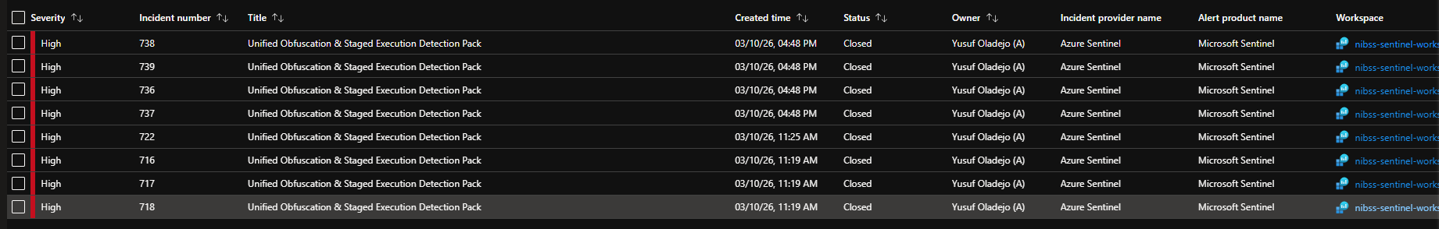

- Was the command line present in logs? If not, what logging gap exists?
- Did entity mapping correctly identify host and user?

C.5 Recommendations
List prioritized improvements with owners and target dates (logging, detections, response playbooks, endpoint controls).
Recommendation | Priority (H/M/L) | Owner | Target Date

